WINGMASTER HD™
Our ammunition experts have brought back Wingmaster HD, the one-stop shop in duck and goose high-density shotshell rounds. Testing proves Wingmaster HD delivers the best combination of pellet energy and pattern density resulting in high pattern energy on target. At 12 g/cc, our tungsten blend is 6% denser than lead and nearly 50% denser than steel. Wingmaster HD features higher retained energy, with uniform, smooth, round pellets for dense and efficient patterns. Expect deeper penetration and more pellets on target. If you want the most balanced tungsten waterfowl shotshell on the market, Wingmaster HD delivers.
FEATURES
- HIGHER RETAINED ENERGY - Denser than lead with excellent patterns
- ROUND, SMOOTH TRUE-SIZED PELLETS - Dense, efficient patterns with deep penetration
- DEEPER PENETRATION AND MORE PELLETS ON TARGET - Equal energy of 3 shot sizes smaller than steel
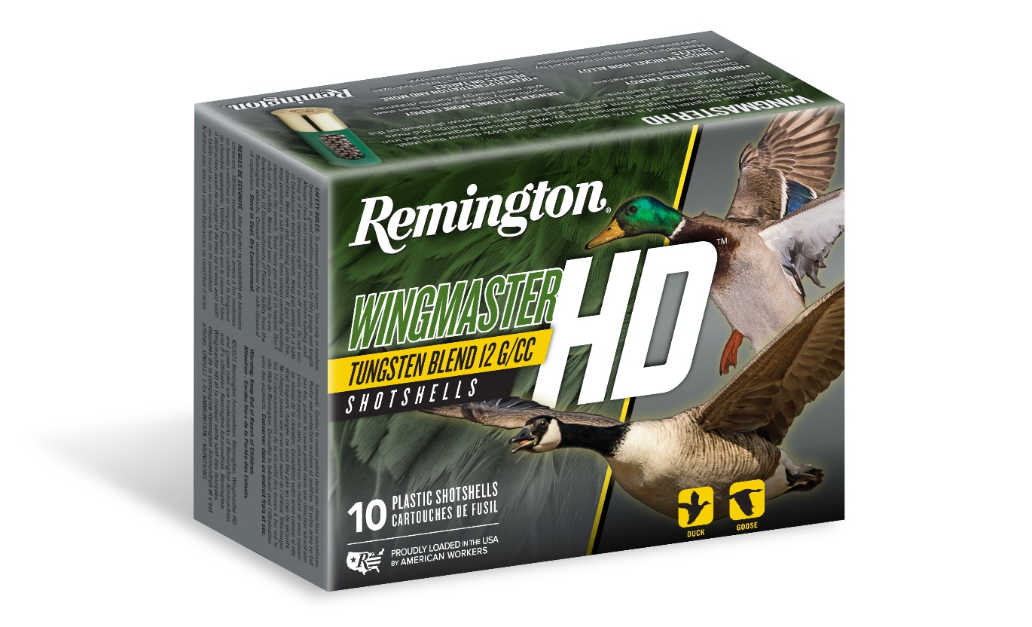
ORDER # | DESCRIPTION | UPC | MSRP
20693 | WINGMASTER HD 12GA 2-3/4IN 1-1/4OZ 4 | 0-47700-34460-7 | $61.99
20695 | WINGMASTER HD 12GA 2-3/4IN 1-1/4OZ 6 | 0-47700-34470-6 | $61.99
20871 | WINGMASTER HD 12GA 3IN 1-1/4OZ 2 | 0-47700-34420-1 | $51.99
20873 | WINGMASTER HD 12GA 3IN 1-1/4OZ 4 | 0-47700-34430-0 | $51.99
20875 | WINGMASTER HD 12GA 3IN 1-1/4OZ 6 | 0-47700-34440-9 | $61.99
20685 | WINGMASTER HD 12GA 3IN 1-3/8OZ 2 | 0-47700-34330-3 | $70.99
20687 | WINGMASTER HD 12GA 3IN 1-3/8OZ 4 | 0-47700-34340-2 | $70.99
20689 | WINGMASTER HD 12GA 3IN 1-3/8OZ 6 | 0-47700-34880-3 | $70.99
20903 | WINGMASTER HD 12GA 3IN 1-1/2OZ 2 | 0-47700-34390-7 | $76.99
20905 | WINGMASTER HD 12GA 3IN 1-1/2OZ 4 | 0-47700-34400-3 | $76.99
20655 | WINGMASTER HD 12GA 3-1/2IN 1-3/4OZ BB | 0-47700-34760-8 | $86.99
20657 | WINGMASTER HD 12GA 3-1/2IN 1-3/4OZ 2 | 0-47700-34770-7 | $86.99
20659 | WINGMASTER HD 12GA 3-1/2IN 1-3/4OZ 4 | 0-47700-34870-4 | $86.99
20763 | WINGMASTER HD 20GA 3IN 1-1/8OZ 4 | 0-47700-34520-8 | $49.99

